**Programmer Manual for Project 3**

**How to run the code:**

* Get a copy of the following files:
  + **Proj3.ASM**
  + **iofar.lib**
  + **compile.bat**
* Save the files to the following drive path: **C:\tasm\tasm\cs221\p3**
* Click on the **DOS box** icon and watch the console open.
* At the DOS box prompt, make sure to change directory to your **P3** file with the specified path listed.
  + Console should now look like this:

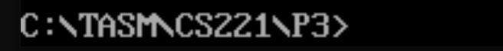

* To Assemble and Link the source file, type the following line:

**compile**

* + Console should now look like this:

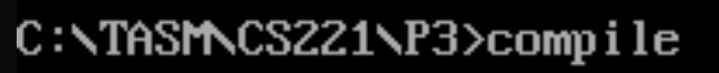

* **Press enter key, Proj3.EXE is now generated,** to run the program at the prompt type:

**Proj3**

**When the program executes:** The program will prompt the user for:

- a positive integer: **Num** (Num should be >= 0).

**Note**: if user input is negative integer, the user will be asked to try again.

**Major Procedures used:**

* **Find_Fib procedure (recursive procedure)**
  + **int Find_Fib (Num);**
* **Greet procedure**
  + **void Greet();**

**Structure of the Code:**

* Call procedure **Greet** to print introductory messages to the user.
* Receive Variable **Num** and do error checking and error recovery.
* Callprocedure **Find_Fib** to compute the nth value of the Fibonacci series.

**Functionality of certain aspects of the code as to the project requirements:**

* It will prompt user for inputting variable: **Num**.
* Check if input value is negative, if user input is negative integer, the user will be asked to try again.
* The recursiveprocedure **Find_Fib (Num)** is to compute the Fibonacci series of by the input **Num**.
* Procedure **Find_Fib** uses a recursive algorithm.
  + Base Cases: **f(0) = 1 and f(1) = 1.**
  + Recursive Case: **f(n) = f(n-1) + f(n-2)**
* **Ex:**

**Input: Series:**

0: 1

1: 1 1

2: 1 1 2

3: 1 1 2 3

4: 1 1 2 3 5

5: 1 1 2 3 5 8

6: 1 1 2 3 5 8 13

7: 1 1 2 3 5 8 13 21

* **Note**: for example, if input is 7, the series will display from f(0) to f(7), total is 8 numbers in the Fib series.